
Senate Resolution No. 2025/2026 - 118
Recognizing May as National Foster Care Awareness Month
Primary Sponsor
Abigail Verino (ASUC President)
Cosponsors
Sara Teran (ASUC Senator), Abdullah Memon (ASUC Senator), Kianna Rodarte (ASUC Senator), Abigail Cho (ASUC Senator), Sydnee Thy (ASUC Senator) Ryan Justice-Williams (Legislative Director for Office of ASUC Senator Memon), Kenny Kutter (External Director of the Southeast Asian Caucus), Anamaria Abnusy (ASUC Senator),

WHEREAS, President Ronald Reagan established May as National Foster Care Awareness Month in 1988, aimed at spotlighting the experiences and needs of children in foster care in order to raise awareness about challenges they face, encourage policies and initiatives that improve the wellbeing of foster youth and increase their prospects for a stable, loving home, and acknowledge the dedication of foster parents, social workers, and advocates; and,

WHEREAS, about 1 in 6 (17%) of foster care youth were phys­i­cal­ly abused, 10% were sex­u­al­ly abused, 7% were emo­tion­al­ly abused and 2% expe­ri­enced med­ical neglect, leaving former foster care youth at a much higher risk to experience mental, physical, and emotional challenges at higher rates compared to non-foster peers; and,

WHEREAS, there are over 60,000 children in the foster care system in California and the state’s on-time graduation rate for foster youth is 53% compared to the state’s 83% average high school graduation rate by youth; and only 3% to 6% of foster youth earn a college degree compared to 50% of the general population; and,

WHEREAS, time to graduation and overall graduation rates are worse for youth with foster care experience than for their first-generation, low-income peers, with just 3.6% of adults who’d once been in the state foster system had earned diplomas from a four-year university by the age of 23; and,

WHEREAS, Berkeley Hope Scholars is an academic retention program founded in 2005 focused on supporting all incoming/continuing undergraduate and graduate students who are current or former foster youth, probation foster youth, or orphaned before the age of 18 by creating a safe, welcoming space and providing students with resources; and,

WHEREAS, Berkeley Hope Scholars has served over 360 students since its founding, currently serves 151 undergraduate students and 29 graduate and professional students, and has an 82% undergraduate graduation rate; and,

WHEREAS, former foster youth experience significant barriers to higher education, including being more likely to face food insecurity compared to non-foster peers, and the process for securing affordable housing accommodations year-round through Berkeley Housing is difficult for foster youth to navigate due to lack of options, leaving these students at risk during academic breaks; and,

WHEREAS, Berkeley Hope Scholars is able to assist foster youth in overcoming barriers to such as food and housing insecurities, as Class of 2024 attests to having “a safe place to rest when completely exhausted, eat something, and get some support when most needed during semester high stress times”; and,

WHEREAS, former foster youth often enter college with a "survivalist" approach, with many students entering college without a stable, supportive network of adults who can provide advice, programs such as Hope Scholars serve as a vital service to former foster youth in higher education, as Class of 2025 Berkeley Hope Scholar testifies to “having people who understood what I had been through has helped me heal from a great deal of trauma”; and,

WHEREAS, there is a lack of necessary allyship in policies and practices across various campus departments to sufficiently address the unique challenges former foster youth face, leading to generalized approaches that can inadvertently and negatively impact this community; and,

WHEREAS, Berkeley Hope Scholars engages in meaningful and impactful work that addresses the needs of the foster youth community, which Class of 2025 Berkeley Hope Scholar reaffirms in saying the program has had a “direct and meaningful impact on [their] academic success and overall well-being”; and,

THEREFORE BE IT RESOLVED, the Associated Students of the University of California (ASUC) officially recognizes the month of May as National Foster Care Awareness Month; and,

THEREFORE BE IT FURTHER RESOLVED, the Senate reaffirms its commitment to uplifting the voices of all CE3 affiliated programs and students, including the Berkeley Hope Scholars, through inclusion in ASUC spaces, events specially catered for these voices, and similar actions; and,

THEREFORE BE IT FURTHER RESOLVED, the Senate calls upon the Executive Vice President, as Chair of the Senate, to establish a working relationship with the Berkeley Hope Scholars, and to invite a program representative to present to the Senate no later than the second meeting of April, beginning with the 2026-27 Senate term; and,

THEREFORE BE IT FURTHER RESOLVED, the Association formally calls upon the university administration to further support foster students through support for CE3 affiliated programs, financial aid, and other support services that research shows drastically improves former foster youth retention and graduation rates; and,

THEREFORE BE IT FURTHER RESOLVED, copies of this resolution shall be delivered to Chancellor Rich Lyons, Interim Vice Chancellor for Equity and Inclusion Fabrizio Mejia, and other relevant members of university administration.

THEREFORE BE IT FINALLY RESOLVED, Operational Policy “POLICY-008: Senate Guest Speakers” will be amended by the Executive Vice President and authors of this bill to include Berkeley Hope Scholars as a Senate guest speaker recommendation, among other guest speakers recommended.

Appendix A

UC Berkeley Hope Scholars Data Sheet FY 25’

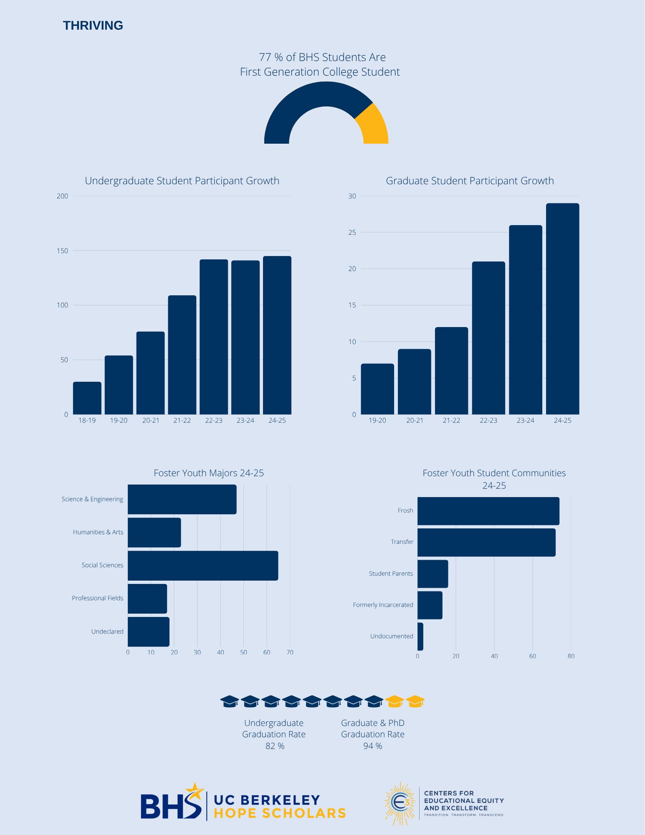

Appendix B


ASUC Berkeley Hope Scholars Info Sheet
Challenges:
- Barriers to Stable Housing
  - Access to uninterrupted, year-round housing remains a critical challenge. Currently, Berkeley Housing does not offer affordable year-round options; for instance, Anchor House is limited to a single academic year. Furthermore, the process for securing necessary housing accommodations is often difficult to navigate, leaving students at risk during academic breaks

- Increasing Allyship
  - Current policies and practices across some campus departments lack the necessary allyship to address the unique needs of former foster youth. This gap often leads to generalized approaches that can inadvertently and negatively impact this community.
Student Testimonials
Thank you all for everything, I appreciate what Hope Scholars is doing, it’s critical and transformative. The time for some of the little things, like dinners, buying my graduation regalia, getting us lifetime memberships (umm, I’m using any and all perks, including the UC libraries to continue my research!! What, what?!?) - and even having a safe place to rest when completely exhausted, eat something, and get some support when most needed during semester high stress times. Thank you for everything, deeply grateful for your efforts, and continued work to reduce poverty and lift up people through education. Class of 2024
Berkeley Hope Scholars has changed my life. This is my first time being part of a community of other foster youth. Learning about myself from them, and having people who understood what I had been through has helped me heal from a great deal of trauma and it expanded my ability to perform academically, professionally, and just be a happier, healthier person. Thank you for providing the means for this community to flourish! Class of 2025
Thank you for being there for our community--we need all the support we can get. I truly appreciate the generosity of the donors who make this program possible. Your contributions have had a direct and meaningful impact on my academic success and overall well-being because the Berkeley Hope Scholars have been a key pillar in my life. Thank you for investing in my education and future! Class of 2025

SR 25/26-001 Advocacy Agenda
https://www.jstor.org/stable/10.2307/48623722?seq=1&cid=pdf-reference#references_tab_contents
https://nationalcasagal.org/may-is-national-foster-care-month/
https://chsnc.org/news/foster-care-awareness-month-the-facts/
https://hope.berkeley.edu/
https://www.clccal.org/resources/foster-care-facts/
Appendix A
https://hope.berkeley.edu/
Appendix A
https://hope4college.com/wp-content/uploads/2018/09/Wisconsin-HOPE-Lab-Still-Hungry-and-Homeless.pdf
Appendix B
Appendix B
Appendix B
Appendix B
https://www.aecf.org/blog/child-welfare-and-foster-care-statistics?gad_source=1&gad_campaignid=10100825713&gbraid=0AAAAAD3xzvFI-EJbbIOBib4hI-qP35nPN&gclid=CjwKCAjwhLPOBhBiEiwA8_wJHEMImk5GitgvH6X0XaBZWaEv0xbFele0SbPgKTdWhKRVHE6CmqbFuBoCfHsQAvD_BwE
https://tcf.org/content/report/college-affordability-challenges-facing-youth-experience-foster-care/#easy-footnote-bottom-27-41487
Appendix B
http://news.berkeley.edu/2025/12/16/for-20-years-this-uc-berkeley-program-has-helped-students-whove-been-in-foster-care-succeed/

