
Senate Resolution No. 2025/2026 - 107
Urging UC Administration to Fully Implement California Senate Bill 98, the Sending Alerts to Families in Education (“SAFE”) Act

Primary Sponsor
Sara Terán (ASUC Senator) and Rayne Xue (ASUC Senator)
Cosponsors
Abigail Verino (ASUC President), Duke Dela Rosa (EAVP Federal Government Relations Director, UCSA Legislative Director), Clarinde Sanft (EAVP Deputy Chief of Staff, UCSA Legislative Director), Abdullah Memon (ASUC Senator), Allison Champ (ASUC Cultural Diversity Affairs Commission Chair), Sydnee Thy (ASUC Senator), Sydney Scott (ASUC Senator), Nhi Tran (International Affairs Director at the Office of Senator Xue), Jada Yang (ASUC Senator), Sameeha Ahmed (ASUC Mental Health Commission Chair), Colton Beardsley (ASUC Senator),
Alexandra Lu (Legislative Director at the Office of Senator Xue), Britnee Stephen (ASUC Student Advocate), Abigail Cho (ASUC Senator), Kianna Rodarte (ASUC Senator)

WHEREAS, California Senate Bill (SB) 98, the Sending Alerts to Families in Education (“SAFE”) Act, was signed into law by Governor Newsom on September 20, 2025, with an urgency clause making it effective immediately; and,

WHEREAS, SB 98 requires that institutions notify “all students, faculty, staff, and campus community members” when law enforcement presence is confirmed on campus. Notifications must include the date and time of confirmation, the location, and hyperlinks to resources available to support students and families; and,

WHEREAS, the text of SB 98 directs notification “as soon as possible” upon confirmation of immigration enforcement presence; and,

WHEREAS, the Legislature enacted SB 98 after finding that “(a) California is responsible for ensuring access to a quality education,” and “(b) Ensuring access to a quality education includes creating a safe and an inclusive campus environment for all students, regardless of their backgrounds or origins;” and,

WHEREAS, the Legislature identified a critical gap that while schools and higher education institutions in California had guidelines for individuals regarding their rights and how to engage with law enforcement agents on campus, there were “no requirements for school or campus administration to inform the campus community of their presence on campus;” and,

WHEREAS, SB 98 was designed to close aforementioned gap and maintain a safe environment in the classroom, where all students deserve peace of mind regardless of immigration status; and,

WHEREAS, UC Berkeley enrolls a diverse number of students from communities that are emotionally and psychologically impacted by the presence of immigration enforcement including , but not limited to Immigrant, Undocumented, International, and students from mixed status families; and,

WHEREAS, UC Berkeley currently enrolls enrolls 7,302 total international students as of Fall 2025, consisting of 3,204 undergraduate, 3,823 graduate, and 275 exchange students; and,

WHEREAS, UC Berkeley currently enrolls enrolls nearly 500 undocumented students as of Fall 2025; and,

WHEREAS, UC Berkeley also enrolls innumerable students from communities that are emotionally and psychologically impacted by the presence of immigration enforcement, including but not limited to students from mixed status families and other immigrant students; and,

WHEREAS, several UC administrators have indicated that notifications of federal immigration enforcement will not be preemptive or real-time, but instead characterized as post-hoc communications distributed via campuswide email rather than emergency alert systems, raising serious concerns that such emergency-level notifications could arrive hours (or even days) after the triggering event; and,

WHEREAS, on January 23, 2026 UC Berkeley administrators sent out a campus-wide email (See Appendix A) entitled “SB 98 Notification Regarding Federal Immigration Enforcement” to all students, staff and faculty, but fails to disclose clear timelines, communication protocols, and whether UCPD could be expected to protect students; and,

WHEREAS, the University of California, Berkeley does not formally require nor have formalized training modules for administration, campus leaders, or dorm Residential Assistants on SB 98 obligations and steps to go about reporting immigration enforcement; and,

WHEREAS, given that federal immigration agents recently entered a dorm in Columbia University and detained an international student on February 26, 2026, the lack of residential protection against immigration enforcement in UC Berkeley residential halls is particularly alarming and leaves residential immigrant students vulnerable in their own home; and,
WHEREAS, the Undocumented Student Program (USP) has already created a training procedure for RAs in the case of immigration enforcement presence that is not yet implemented; and,

WHEREAS, international, undocumented, and immigrant students report feeling unsafe on the UC Berkeley campus due to the lack of protective measures against Immigration Enforcement; and,

WHEREAS, the UC and CSU system saw a decline of undocumented student enrollment of around 50% since 2016 across campuses, with UC system campuses seeing a decline from 1100 students to 500 and the CSU campuses seeing a decline of 2200 to 1100; and,

WHEREAS, the downward decline witnessed throughout California are strongly correlated with concerns of safety and barriers by the state and federal government; and,

WHEREAS, other public university campuses such as CSU San Marcos already have measures to mobilize their campus police department to verify reported sightings of immigration enforcement activity on or near campus and issue timely notifications; and,

WHEREAS, CSU San Marcos also exemplified an efficient implementation of a Rapid Response Network that directs immigration enforcement officers to the campus police department and utilizes University resources to protect students; and,

WHEREAS, the aforementioned email states that the university “cannot prevent federal officers from accessing public areas of campus or impede their activities. What we can do is provide you with information about your rights, connect you to legal resources, and ensure you know how to access support. UCPD's role is focused on campus safety — they do not participate in immigration enforcement or inquire about immigration status;” and,

WHEREAS, this statement, while clarifying that the University will not impede federal enforcement and that UCPD does not participate in immigration enforcement, introduces ambiguity as to whether the University will make a firm and formalized commitment to proactively mobilize UCPD and other institutional resources to verify and respond to reported sightings of ICE on or near campus; and,

WHEREAS, incidents of unsubstantiated ICE presence rumor on UC Berkeley campus, such as in April 2025 and January 2026, instigated fear in the student community and proves the exigency of employing UCPD for verification of ICE activities; and,

WHEREAS, that the University is cautious to deliver notifications of “unverified” immigration enforcement activity is an insufficient justification for delayed notifications when student safety is at stake, and only proves the exigency for UC Berkeley to expedite both the verification and campus notification processes; and,

WHEREAS, upholding campus safety for immigrant students is not a partisan issue, but a matter of complying with state laws and maintaining equitable access to education opportunities.

THEREFORE BE IT RESOLVED, that the Associated Students at the University of California (ASUC) demands that UC Berkeley mobilizes UCPD and University resources to verify reported sightings of immigration enforcement activity on or near campus and issue timely notifications, consistent with practices adopted at other campuses such as CSU San Marco; and,

THEREFORE BE IT RESOLVED, that the ASUC urges UC Berkeley Residential Life to implement formularized training modules on SB 98 obligations for Residential Assistants (RAs), after consultation with the Undocumented Student Program, to be adequately prepared to report and respond to immigration enforcement activity on or near the residential dorms, in accordance with USP recommendations; and,

THEREFORE BE IT RESOLVED, that such trainings be incorporated as part of the Blue Residential Assistant Fall and Spring Hall Staff Training, ensuring Residential Assistants are well-prepared to respond to these emergency situations on residential campus property; and,

THEREFORE BE IT FURTHER RESOLVED, that the ASUC urges the Division of Undergraduate Education to update Classroom Emergency Standards to include SB 98 obligations and guidelines so GSIs, professors, and instructors are trained on how to respond appropriately in the event of immigration enforcement activity; and,

THEREFORE BE IT FURTHER RESOLVED, that the ASUC directs President Abigail Verino, External Affairs Vice President Calvin Yang, appointed Legislative Directors within the University of California Student Association (UCSA), and future individuals holding those positions to oversee the continued advocacy for and completion of the above mentioned action items; and,

THEREFORE BE IT FINALLY RESOLVED, the ASUC urges the campus of UC Berkeley, UC Berkeley Chancellor Rich Lyons, Executive Vice Chancellor and Provost Ben Hermalin, Vice Provost for Undergraduate Education Oliver O’Reilly, Vice Chancellor of Student Affairs Stephen Sutton, Acting Vice Chancellor of Equity and Inclusion Fabrizio Mejia, and Associate Vice Chancellor of Health and Wellbeing Cory Vu, Demonstrations and Students Action Committee Chair Trond Petersen, Demonstrations and Students Action Committee Laurel Fletcher, Director of Residential Life Glenn De Guzman, and all future individuals holding these listed positions to support measures that protect immigrant and international students.

Appendix A
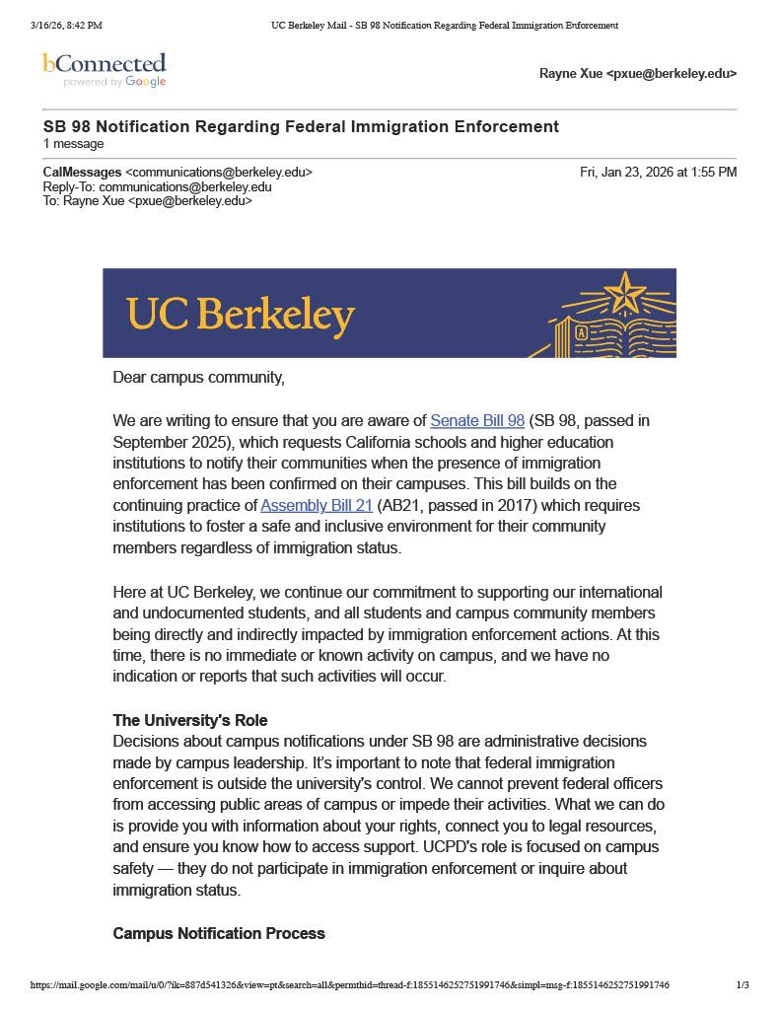
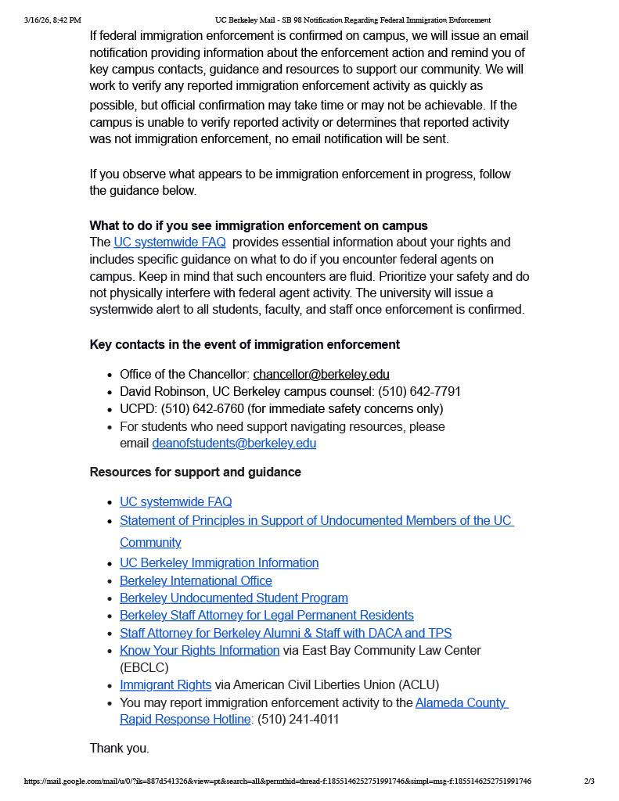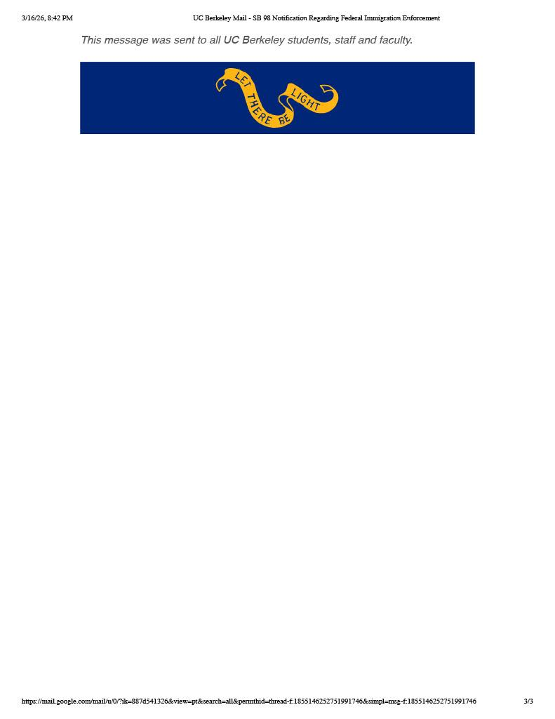

https://leginfo.legislature.ca.gov/faces/billNavClient.xhtml?bill_id=202520260SB98
https://leginfo.legislature.ca.gov/faces/billNavClient.xhtml?bill_id=202520260SB98
(Cal. Sen. Bill 98, 2025–26 Reg. Sess., §§ 1–2 & bill analyses)
Bill Text: CA SB98 | 2025-2026 | Regular Session | Amended | LegiScan
https://leginfo.legislature.ca.gov/faces/billNavClient.xhtml?bill_id=202520260SB98
International Student Enrollment Records, Berkeley International Office, Fall 2025
CSU San Marcos: Responding to Immigration Enforcement on Campus | Support & Services
Ellie Aghayeva: What we know about the Columbia student’s detention by ICE agents | CNN
Enrollment of Undocumented Students at California Universities Dropped from 2016 to 2023 | UC Davis
Undocumented Student Program.
Protect international students so they don’t ‘walk on eggshells’ in fear of ICE | Opinion
Responding to Immigration Enforcement on Campus | Support & Services
Faculty Resource for Classroom Emergency Preparedness
ICE presence unsubstantiated after rumors spread at UC Berkeley | Campus | dailycal.org
Rumors of ICE in Berkeley unfounded | City | dailycal.org
Blue Resident Assistant - Residential Life

