
Senate Resolution No. 2025/2026-036
Reallocating the Remaining $296,997.54 of Cal Lodge Sale Revenue to the ASUC Investment Portfolio

Primary Sponsors
Isha Chander (ASUC Executive Vice President)
Jonathan Ngai (ASUC Chief Financial Officer)

WHEREAS, the Associated Students of the University of California (ASUC) previously owned and operated a property (hereinafter referred to as “Cal Lodge”) located at 198181 Donner Pass Rd, Norden, CA 95728; and,

WHEREAS, the ASUC Chief Financial Officer in 2016-2017 made a directive to sell the property, rooted in concerns with operational inefficiency and financial sustainability; and,

WHEREAS, in accordance with Senate Resolution 2017/2018-049, the ASUC sold Cal Lodge for $502,000.00 in 2018; and,

WHEREAS, ​The ASUC investment portfolio generates significant, growing returns through interest, dividends and asset appreciation which are allocated to ASUC bodies and Registered Student Organizations (RSOs) through the Annual Budgeting and Space Allocation (ABSA) Process each year; and,

WHEREAS, ​Securing the financial well-being of the ASUC is of the utmost importance in order to continue supporting student initiatives; and,

WHEREAS, in accordance with Senate Resolution 2017/2018-050, a portion of the revenue from the property sale was allocated for the purchase of the BerkeleyTime platform, an online class planning service for Berkeley students managed by the ASUC Chief Technology Office; and,

WHEREAS, the ASUC has not made use of the remaining Cal Lodge proceeds since 2018, leaving the funds inactive and not generating meaningful returns for the student body; and,

WHEREAS, the remaining revenue from the Cal Lodge sale currently resides in the ASUC Commercial Revenue Account in the amount of $296,997.54 (refer to Appendix A), which is restricted under ASUC accounting practices, preventing the ASUC from deploying these funds; and,

WHEREAS, the ASUC Investment Portfolio was valued at approximately $3.8 million as of June 30, 2025 by the ASUC Student Union Financial Advisor, demonstrating strong performance and the capacity of the portfolio to generate reliable recurring revenue for ASUC programs and student organizations; and,

WHEREAS, the ASUC Executive Vice President and Chief Financial Officer, in their capacities as the association’s chief stewards of internal operations and financial management, have identified reallocation of the Cal Lodge Funding as essential for the long-term fiscal health of the ASUC.

THEREFORE BE IT RESOLVED, that the $296,997.54 of remaining revenue from the Cal Lodge sale be transferred to the ASUC Investment Portfolio to serve as a long-term endowment generating recurring revenue for ASUC bodies and RSOs; and,

THEREFORE BE IT FURTHER RESOLVED, that once the funds are transferred, they shall inherit all restrictions applicable to the ASUC investment portfolio account in which they reside (including, but not limited to, prohibitions on investment in weapons manufacturers, corporations in violation of BDS guidelines, and fossil fuel companies) and that the original Cal Lodge Revenue Account shall be formally closed; and,

THEREFORE BE IT FINALLY RESOLVED, the Chief Financial Officer shall execute the necessary accounting transfers to unrestrict the Cal Lodge Revenue Account and incorporate the funds into the ASUC Investment Portfolio.

Appendix A (Cal Lodge Account Total)

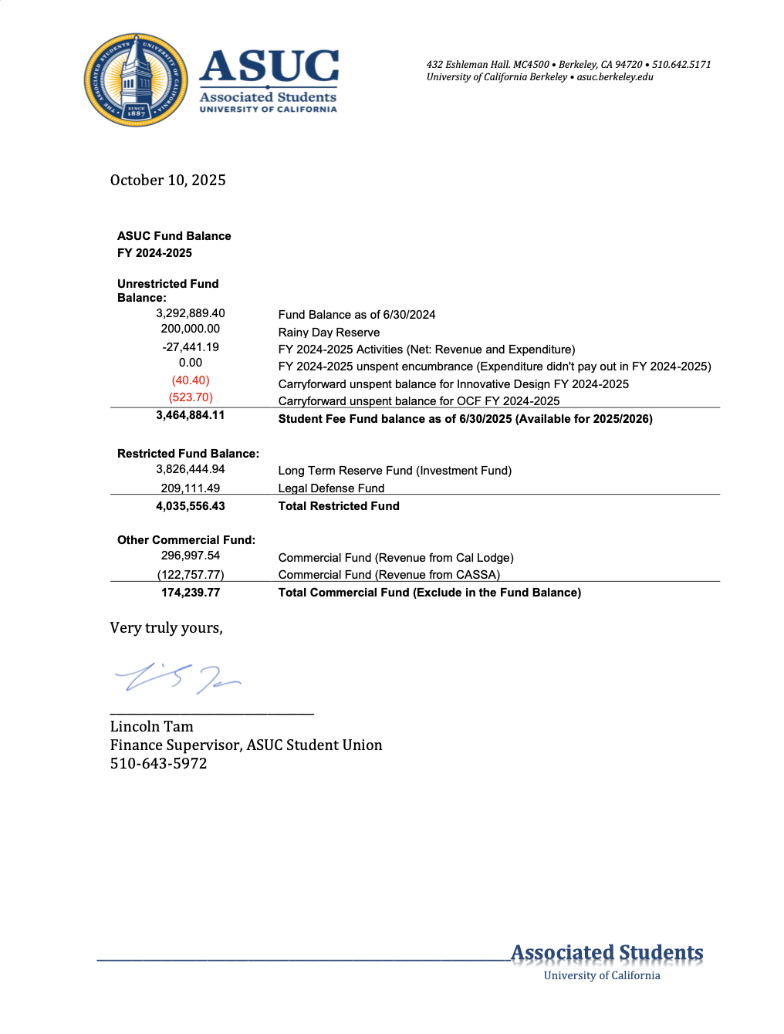

SR 24/25-003 Supporting ASUC’s Divestment from Weapons Manufacturers and Corporations Violating BDS
SR 17/18-049 Authorizing the Sale of Cal Lodge
SR 17_18-050 Allocation of Cal Lodge Sale Revenue.pdf
SR 16-17-039 In Making Decision for Cal Lodge.pdf

